Advocate.AI – Enhancing Legal Literacy and Rights Awareness Using AI

Sameer Singh Rawat Depertment of Computer Science and Engineering(Artifical Intelligence and

Machine Learning)

KIET Group of Institutions Ghaziabad,India

[sameer.2226cseml1117@kiet.edu](mailto:sameer.2226cseml1117@kiet.edu)

Pooja Chahuhan Depertment of Computer Science and Engineering(Artifical Intelligence and

Machine Learning)

KIET Group of Institutions Ghaziabad,India

[pooja.2226cseml1100@kiet.edu](mailto:pooja.2226cseml1100@kiet.edu)

Devanshu Sharma Depertment of Computer Science and Engineering(Artifical Intelligence and

Machine Learning)

KIET Group of Institutions Ghaziabad,India

[Devanshu.2226cseml@kiet.edu](mailto:Devanshu.2226cseml@kiet.edu)

Shubham Verma

Depertment of Computer Science and Engineering(Artifical Intelligence and Machine Learning)

KIET Group of Institutions Ghaziabad,India

[shubham.2226cseml111@kiet.edu](mailto:shubham.2226cseml111@kiet.edu)

***Abstract*—**

**In India, despite the presence of a robust legal framework, a significant portion of the population remains unaware of their legal rights and entitlements due to complex legal language, limited access to resources, and societal taboos surrounding sensitive issues such as domestic violence and sexual assault. This research presents Advocate.AI, an innovative digital platform designed to bridge the gap between citizens and legal knowledge through the integration of artificial intelligence. The core feature of the platform is an AI- powered legal chatbot that provides instant, simplified, and reliable legal information across various domains such as family law, property law, labor law, and criminal law. Advocate.AI incorporates a Know-Your-Rights (KYR) framework, allowing users to receive context-specific legal guidance and access relevant laws and sections from the Indian Constitution. Additionally, the platform leverages a verification-based system (V-KYC) to ensure trust and security. Through user-friendly design and natural language processing, Advocate.AI aims to democratize access to justice, empower individuals to seek legal support, and strengthen citizen awareness. This paper explores the system architecture, design methodology, real-world implications, and potential for large-scale deployment in collaboration with legal aid bodies and NGOs.**

**Keywords— Legal AI,Know Your Rights, Legal ChatBot,V-KYC,Legal Tech**

1. Introduction

India's legal landscape is vast and diverse, encompassing numerous domains such as family law, property law, labor law, and criminal law. Despite the comprehensive legal framework designed to uphold justice and protect individual rights, a significant portion of the Indian population continues to face barriers in understanding and accessing the legal system. These barriers stem from factors such as

complex legal jargon, lack of awareness, fear of social stigma, and limited outreach of legal aid services. As a result, many individuals, especially those from marginalized communities or victims of sensitive issues like domestic abuse and sexual harassment, refrain from seeking justice.

To address this critical gap, **Advocate.AI** has been developed as an AI-powered legal assistance platform aimed at democratizing legal knowledge and promoting access to justice. The platform features an intelligent chatbot capable of understanding natural language queries and providing accurate legal information, relevant case laws, and rights- based guidance. At its core, Advocate.AI incorporates a **Know-Your-Rights (KYR)** framework that educates users about their legal rights based on their specific situations. Moreover, a built-in **Verification-Know-Your-Citizen (V- KYC)** mechanism ensures a trustworthy and secure user experience.

The primary objective of this paper is to present Advocate.AI as a scalable and inclusive solution to enhance legal literacy and bridge the gap between citizens and the justice system. This paper explores the motivation, technical design, architecture, legal relevance, and the transformative potential of deploying Advocate.AI in real-world socio-legal contexts..

1. Related works

Globally, several AI-driven platforms have emerged to simplify legal processes. **DoNotPay**, known as the world’s first robot lawyer, provides users with automated assistance for resolving everyday legal issues like traffic tickets and subscription cancellations. Similarly, **ROSS Intelligence**, built on IBM Watson, enabled legal professionals to conduct natural language legal research more efficiently. These platforms have demonstrated the potential of artificial intelligence in increasing accessibility and reducing the complexity of legal services.

In India, the legal-tech landscape is growing, but most platforms such as **MyAdvo**, **LawRato**, and **Vakilsearch** focus on connecting users to lawyers or offering standardized legal documents. While helpful, they lack interactive educational tools to help citizens understand their rights. Government initiatives like **Tele-Law** and **Nyaya Bandhu** attempt to bridge the access gap but often suffer

XXX-X-XXXX-XXXX-X/XX/$XX.00 ©20XX IEEE

from limited digital infrastructure, language barriers, and lack of awareness among the public.

Existing solutions are primarily lawyer-centric, offering little to no support for **legal literacy or real-time conversational assistance** for common citizens. This is the critical gap that **Advocate.AI** addresses. It uniquely blends **Natural Language Processing (NLP)**, a **Know-Your- Rights (KYR)** framework, and **V-KYC** verification to deliver personalized, rights-based information. Unlike prior works, Advocate.AI is designed to empower individuals to understand and act upon their legal rights — without fear, jargon, or delay.

1. Proposed design and architecture
2. *System Overview*

Advocate.AI is designed as a modular, AI-driven legal assistance platform that offers real-time, user-friendly legal information to Indian citizens. The core objective is to bridge the knowledge gap by providing simplified and context-aware legal guidance using a conversational chatbot interface. The platform is structured around four primary components: the Legal AI Chatbot, the Know- Your-Rights (KYR) Framework, the V-KYC User Verification Module, and the Lawyer Connect & Case Reference System.

1. *Architecture Diagram*

The system architecture follows a client-server model consisting of the following layers:

* + **Frontend Layer**: Built using ReactJS or any modern frontend framework, this layer allows users to interact with the chatbot, submit queries, and view responses in multiple Indian languages.
  + **Backend Layer** : Manages request routing, session handling, and communication between different services and APIs. It serves as the bridge between the user interface and the AI engine.
  + **AI Engine :** Built on frameworks like spaCy or HuggingFace Transformers, this module processes natural language queries from users, classifies them, and matches them to relevant legal articles, rights, and previous case rulings.
  + **Database Layer**: Stores user data, V-KYC verification status, interaction logs, KYR content, and indexed legal resources. Ensures fast retrieval and personalized experiences.
  + **V-KYC Module**: A security layer integrated with government ID verification APIs to authenticate users and prevent misuse.
  + **Lawyer Connect API**: Helps in forwarding complex or unresolved queries to verified lawyers through an internal request-routing system.

*C Control Flow Diagram*

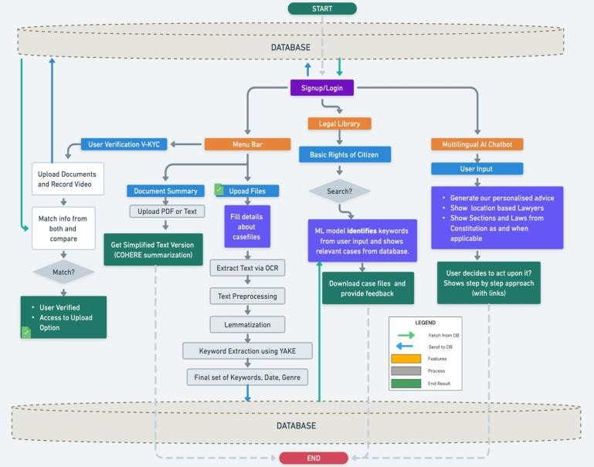

*D. Core Functional Modules*

* **Legal Chatbot Interface**: Accepts user input in plain language, provides instant legal responses, and suggests rights-related information based on KYR content.
* **Know-Your-Rights (KYR) Framework**: A curated database of legal rights categorized by domains (e.g., family law, labor law), each linked to relevant constitutional articles and laws.
* **Contextual Query Matching**: The NLP model not only understands user intent but also identifies the context (e.g., harassment at workplace, property disputes) to deliver more precise legal information.
* **Multilingual Support**: To ensure inclusivity, the platform supports multiple Indian languages using language translation models and local dialect training.
* **Secure User Onboarding**: Users undergo a lightweight V-KYC process to authenticate identity, increasing trust and minimizing legal misuse.

*E .Unique Features*

* **Personalized Rights Feed**: Based on interaction history and query topics, users receive regular updates about their rights and new laws.
* **Case Law Summarizer**: When needed, the system fetches previous relevant case rulings and summarizes them in layman-friendly language.
* **Offline Mode (Future Scope)**: For rural deployment, a lightweight Android version is proposed with offline capabilities for frequently asked legal topics.

*F .Scalability and Security*

The architecture is designed to be **scalable**, with containerized deployment using Docker and orchestration via Kubernetes for handling large-scale user traffic. End-to- end encryption and token-based authentication ensure **data privacy and security**, aligning with legal tech standards and ethical compliance.

1. Future Scope

* **MULTILINGUAL & VOICE-BASED INTERACTION**: ADDITION OF VOICE-ENABLED CHATBOT AND

support for Indian regional languages and dialects to improve accessibility for rural and non-English-speaking users.

# Integration with Government Legal Services:

COLLABORATE WITH PLATFORMS LIKE **TELE-LAW**, **NYAYA BANDHU**, AND **ECOURTS** TO OFFER VERIFIED AND GOVERNMENT-SUPPORTED LEGAL AID.

# Real-Time Lawyer Assistance:

Enable escalation of complex queries to verified lawyers via **LIVE CHAT OR VIDEO CALLS**, bridging the gap between AI and human expertise.

# Support for NGOs & Legal Literacy Campaigns:

Offer NGO-specific dashboards and resources for using Advocate.AI in awareness drives, legal camps, and social work.

# Mobile App with Offline Access:

Develop a lightweight Android application that allows users to access KYR (Know Your Rights) information without internet connectivity.

# Predictive Legal Analytics:

Use AI to forecast legal outcomes based on user-input scenarios, assisting users in understanding potential consequences before filing legal action.

# Gamified Legal Education:

Integrate quizzes, story-based games, and reward systems to promote legal learning, especially for students and youth.

* + **BLOCKCHAIN FOR LEGAL RECORD SECURITY**: USE BLOCKCHAIN TECHNOLOGY TO SECURELY LOG USER INTERACTIONS AND V-KYC VERIFICATIONS, ENSURING DATA INTEGRITY AND TRANSPARENCY.

1. Acknowledgement

We would like to express our sincere gratitude to all those who have supported and guided us throughout the course of this research project, **Advocate.AI**.

First and foremost, we extend our heartfelt thanks to **Dr. Rekha Kashyap**, Dean Academics, AIML Department, for his/her continuous encouragement and for fostering an environment of innovation and learning.

We are deeply grateful to our project mentor, **Mayank Lakhotia ,**whose constant support, expert guidance, and valuable feedback were pivotal in shaping our vision into a practical solution.

Our sincere appreciation also goes to all the **faculty members of the AIML Department**, whose teachings, advice, and motivation provided the foundational knowledge and confidence required to undertake this project.

We would also like to thank the developers of the open- source technologies used in this project, as well as the legal professionals and citizens who shared their insights and helped us validate our solution.

Lastly, we acknowledge our peers, families, and friends for their unwavering support, patience, and belief in us throughout this journey.

1. REFERENCES
2. Surden, H. (2014). *Machine Learning and Law*. Washington Law Review, 89(1), 87–115. https://digitalcommons.law.uw.edu/wlr/vol89/iss1/3
3. Susskind, R. (2019). *Online Courts and the Future of Justice*. Oxford University Press.
4. Agarwal, S., & Jain, A. (2020). *AI in the Indian Legal Sector: Challenges and Opportunities*. International Journal of Law, Management and Humanities, 3(4), 80– 89.
5. Ministry of Law & Justice, Government of India. (2022). *Tele-Law: Reaching the Unreached*. [https://tele-law.in](https://tele-law.in/)
6. Bennett, M., & Deeks, A. (2018). *Artificial Intelligence and National Legal Systems*. Columbia Law Review, 119(4), 887–958.
7. Latham, R. (2021). *The Ethics of AI in Legal Practice*. Harvard Journal of Law & Technology, 34(1), 45–72.
8. Barendrecht, M. (2011). *Legal Empowerment and Human Rights: Complementary Approaches*. Hague Journal on the Rule of Law, 3(1), 36–46.
9. Legal Information Institute (LII). (n.d.). *Indian Constitution and Legal Provisions*. [https://indiankanoon.org](https://indiankanoon.org/)
10. spaCy Documentation. (n.d.). *Industrial-strength Natural Language Processing in Python*. [https://spacy.io](https://spacy.io/)
11. World Justice Project. (2021). *Rule of Law Index*. [https://worldjusticeproject.org](https://worldjusticeproject.org/)